Project Design Phase-II
Data Flow Diagram & User Stories

Date | 31 January 2025
Team ID | LTVIP2026TMIDS82253
Project Name | Deep Learning Fundus Image Analysis for Early Detection of Diabetic Retinopathy
Maximum Marks | 4 Marks

Data Flow Diagrams:
A Data Flow Diagram (DFD) is a traditional visual representation of the information flows within a system. A neat and clear DFD can depict the right amount of the system requirement graphically. It shows how data enters and leaves the system, what changes the information, and where data is stored.

Example: (Simplified)
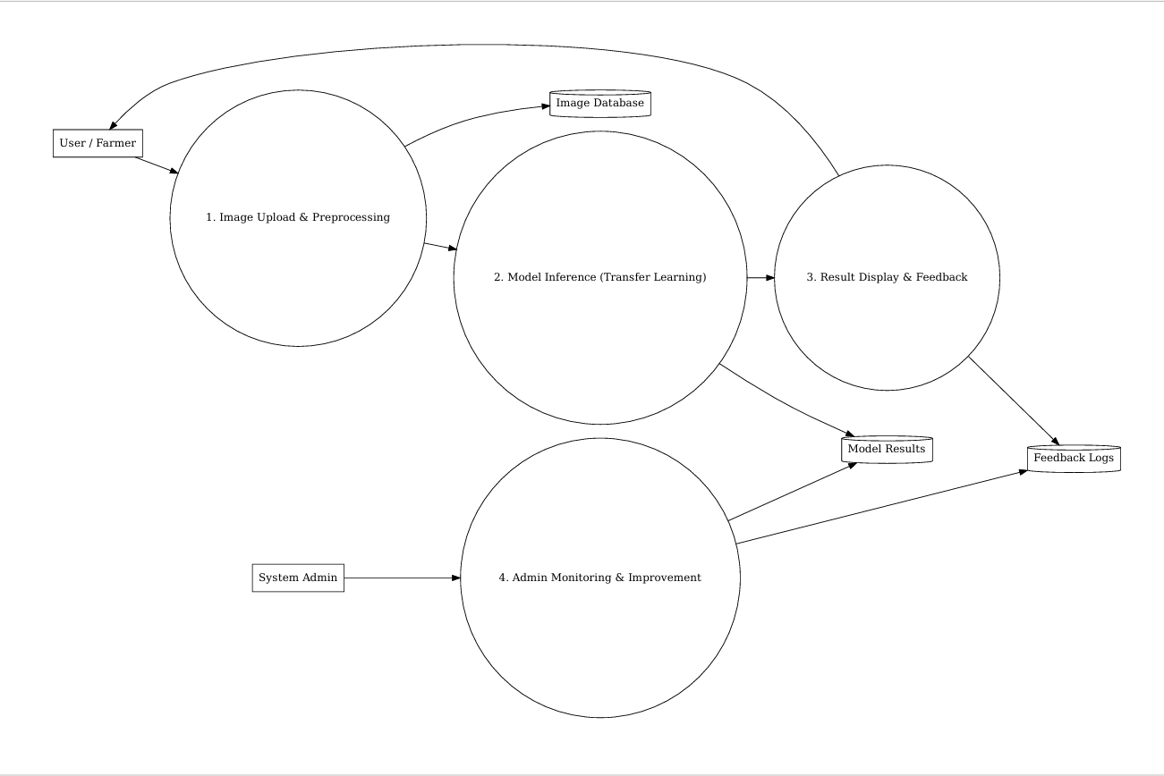
user

User Stories
Use the below template to list all the user stories for the product.
User Type | Functional Requirement (Epic) | User Story Number | User Story / Task | Acceptance Criteria | Priority | Release
Doctor / Healthcare Professional | Registration | DR-US-1 | As a user, I can register using my email and password to access the DR detection system. | User can log in after registering with valid credentials. | High | Sprint-1
Doctor / Healthcare Professional | Registration | DR-US-2 | As a user, I receive a confirmation email after successful registration. | Confirmation email is received and account is verified. | High | Sprint-1
Doctor / Healthcare Professional | Login | DR-US-3 | As a user, I can log in using my registered credentials. | User is redirected to the dashboard after login. | High | Sprint-1
Doctor / Healthcare Professional | Image Upload | DR-US-4 | As a user, I can upload retinal fundus images for analysis. | System accepts fundus image and confirms upload. | High | Sprint-2
Doctor / Healthcare Professional | Prediction | DR-US-5 | As a user, I can view whether diabetic retinopathy is detected from the uploaded image. | DR detection result is displayed with confidence score. | High | Sprint-2
Doctor / Healthcare Professional | Severity Classification | DR-US-6 | As a user, I can see the severity level of diabetic retinopathy. | System displays DR stage (No DR, Mild, Moderate, Severe, Proliferative). | High | Sprint-2
Doctor / Healthcare Professional | Explainability | DR-US-7 | As a user, I can view heatmaps highlighting affected retinal regions. | Grad-CAM or heatmap is displayed with prediction. | Medium | Sprint-3
Doctor / Healthcare Professional | View History | DR-US-8 | As a user, I can view past uploaded images and prediction history. | History is displayed with date, result, and severity. | Medium | Sprint-3
Admin | User Management | DR-US-9 | As an admin, I can view and manage registered users. | Admin panel shows user list with management options. | Medium | Sprint-2
Admin | Monitor Predictions | DR-US-10 | As an admin, I can monitor model prediction logs and performance. | Dashboard shows prediction counts and accuracy trends. | Medium | Sprint-3
Admin | Model Improvement | DR-US-11 | As an admin, I can update datasets and retrain the model. | System supports dataset upload and model retraining. | High | Sprint-4

